Backend technologies

**Eureka Server**

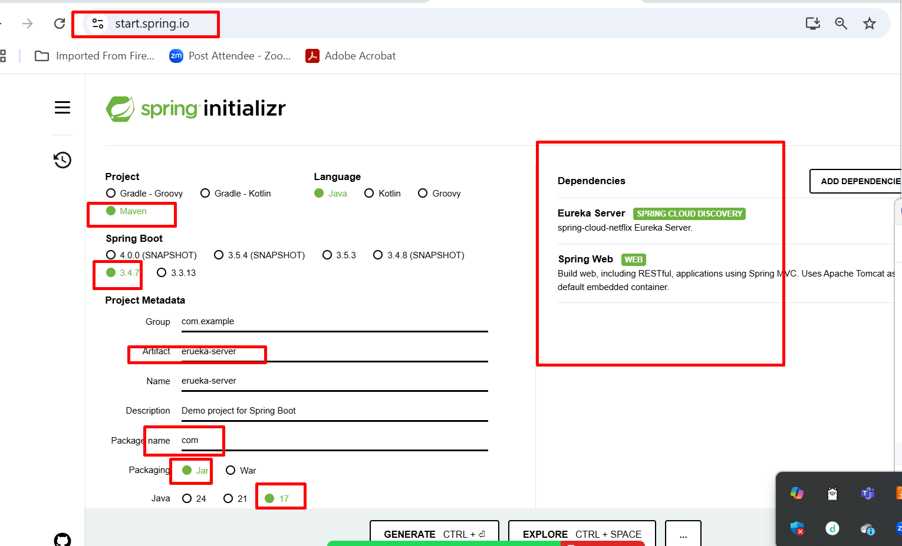

Login micro service application

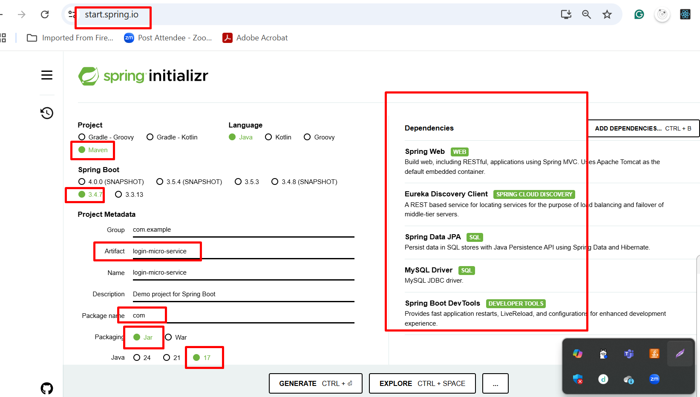

Frontend technologies

Before micro service

Login Module

Dashboard module

customer module

manager module

Payment module

